MX Parking Lot
Current Condition Review and Near-Term Repair Options
Visual review based on April 4, 2026 video clips and the MX parking-lot webpage
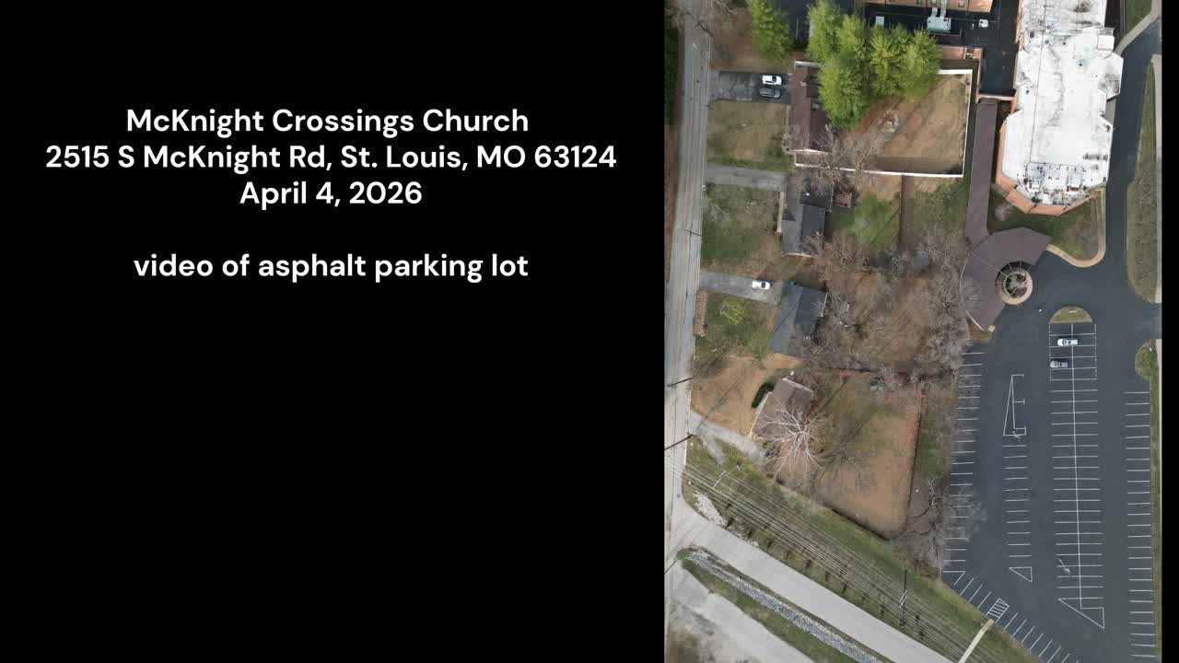
Prepared for Bret Blackford (assistance from ChatGPT)
April 2026

Bottom line: the lot appears serviceable, but it is carrying widespread cracking, multiple failed or aging sealed cracks, and several areas of fatigue/alligator cracking that look beyond simple crack filling alone.
- A targeted maintenance campaign would be worthwhile now. Hot-applied crack sealing appears appropriate for many long linear cracks, while localized patching appears appropriate for select failed spots. Neither product by itself looks like a full-lot cure.

1. Scope and limits of this review
• This assessment is based on a visual review of four video clips taken April 4, 2026 (here), along with the MX parking-lot webpage that documents prior drawings, photos, and 2023 repair history.
• Because this is a visual review only, it should be treated as a practical maintenance opinion rather than an engineering design, coring analysis, or formal pavement condition index study.
• The conclusions below focus on what appears to be most useful and economical in the near term.

2. Background noted on the MX webpage
The MX parking webpage (here) indicates that 2023 bids were requested from several paving firms and shows Gevers Paving as the selected contractor, with a listed patch-and-seal amount of $43,060. The page also links to photos and videos of the October 2023 parking-lot work and related repair details.

3. Overall visual condition
Condition item | What is visible | Practical implication
General surface | The lot is still broadly drivable and striped, but cracking is visible across much of the paved area. | The lot appears usable today, yet the pavement is aging and open cracks are giving water repeated ways into the surface and base.
Linear cracking | There are many long interconnected cracks, including older sealed lines that appear to have reopened or continued to move. | This is a good candidate for selective crack routing/cleaning and hot-applied crack sealing where the pavement edge remains sound.
Fatigue / alligator areas | Several areas show dense spiderweb or alligator-style cracking, especially around wheel paths and localized stressed areas. | These spots usually indicate deeper structural fatigue. Filling the visible cracks alone is unlikely to last long.
Prior repairs | Some previous sealed or patched lines remain visible and seem to have helped in places, but not enough to stop new cracking from spreading. | The lot likely needs another round of targeted work and a clearer maintenance cycle.
Drive lane / entrance areas | The drive-up areas near the building appear smoother overall but still show substantial long crack lines and movement. | These areas may benefit from crack sealing now, while watching closely for settlement or rutting.

4. My overall perception of the lot
• The lot does not look like an immediate emergency replacement case, but it does look well into the stage where deferred maintenance will become more expensive if left alone.
• The biggest issue is not one isolated pothole; it is the breadth of cracking. A lot of the distress appears to be distributed across broad portions of the parking field.
• Some cracking looks like classic working linear cracks that can still be sealed. Other areas look like true fatigue cracking where the asphalt has broken into many small interconnected pieces. Those sections usually require patching, saw-cut removal, or a broader resurfacing strategy.

5. Representative screenshots from the April 4, 2026 video
Aerial opening view showing the overall parking field and general lot layout.
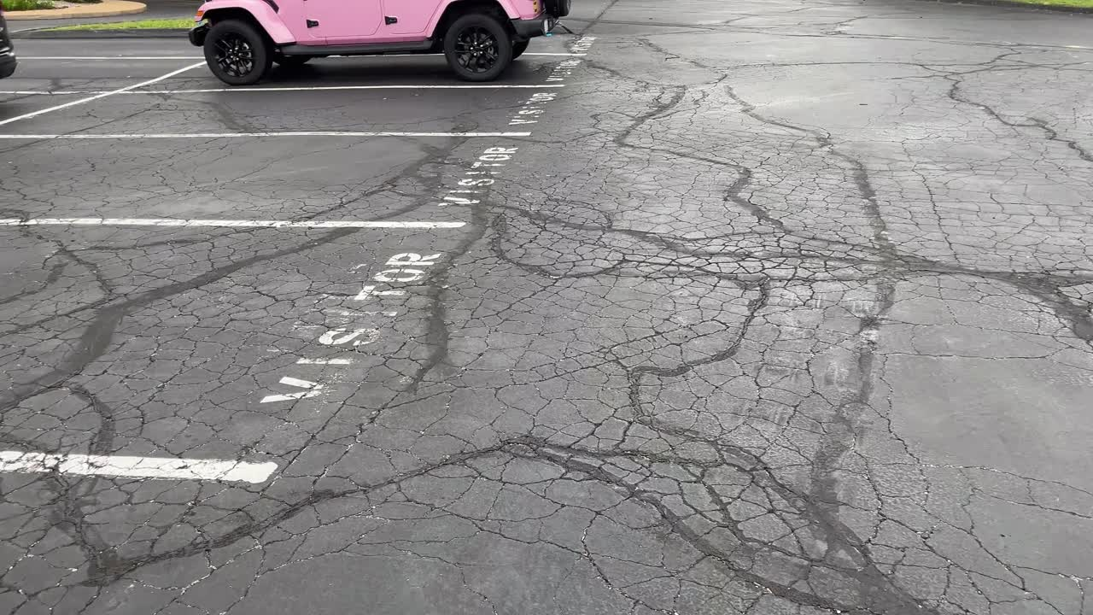
Dense alligator/fatigue cracking in a parking area. This is the type of distress least likely to be solved by crack seal alone.
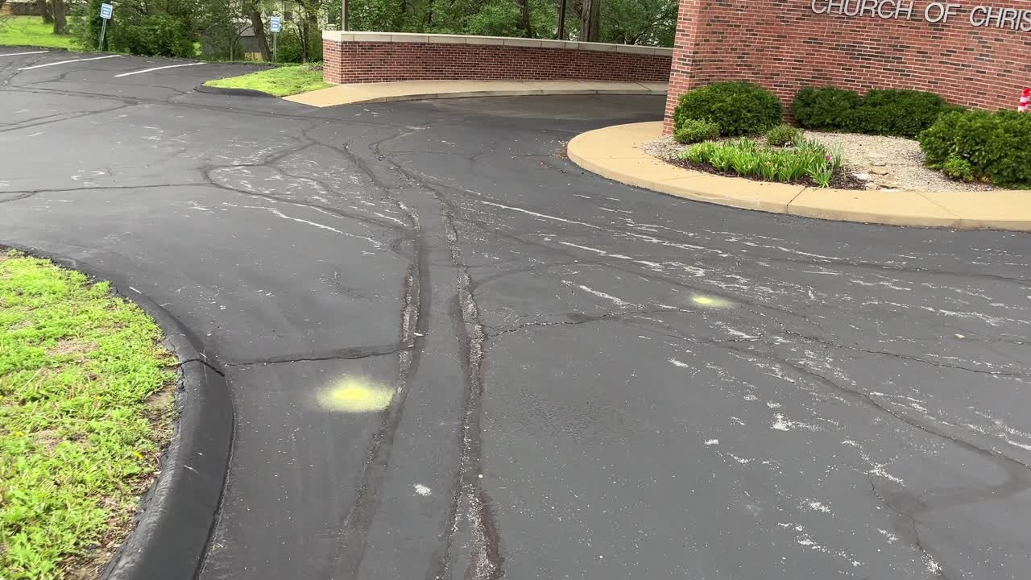
Long working cracks and prior repair lines near the building drive lane.
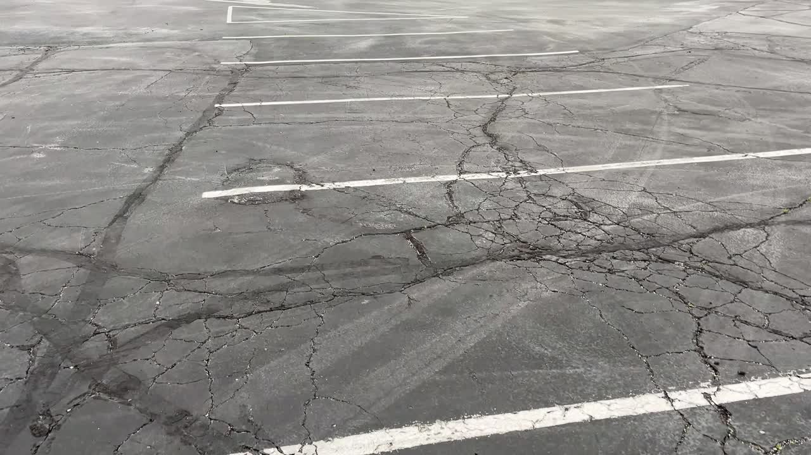
Interconnected cracking across a wider parking area, with both linear and fatigue-like distress visible.

6. Would QPR 6690 hot-applied crack filler be helpful?
• Yes, in the right places. It appears potentially useful for many of the long, open, linear cracks that are still reasonably intact at the edges and have not turned into full alligator failure.
• It appears less suitable as the main treatment for the heavily webbed or shattered sections. In those areas the problem looks deeper than a single crack line; sealing over the pattern may improve appearance briefly but usually does not stop continued breakup.
• If used, the best candidates would be cleaned, dry, clearly defined cracks where the surrounding asphalt is still holding together.

7. Would QPR Permanent Pavement Repair cold patch be helpful?
• Yes, but mainly as a localized repair material. It appears potentially useful for isolated failed spots, pothole-like areas, broken edges of previous patches, or small excavated sections after loose material is removed.
• It does not appear to be the best answer for broad fatigue areas that extend across large sections of parking stalls or lanes. Large alligator areas usually last longer when cut out and repaired more deliberately, or when included in a larger patch/overlay approach.
• Cold patch can still be valuable for triage work, especially where a quick near-term repair is needed before a larger paving season project.

8. Practical repair strategy I would consider
Priority | Area type | Recommended action | Comment
1 | Open linear cracks in otherwise sound pavement | Clean and hot-seal | Good maintenance use of QPR 6690 or similar contractor-grade hot rubber sealant.
1 | Localized failed spots / potholes / broken patch edges | Remove loose material and patch | QPR cold patch may be useful for small isolated failures or temporary-to-medium-term repairs.
2 | Dense alligator cracking clusters | Mark, measure, and patch more substantially | Prefer cut-and-patch, skin patch, or contractor repair instead of treating these as simple cracks.
2 | Large areas with broad distributed cracking | Evaluate for future mill/overlay or resurfacing | If widespread cracking continues, repeated spot repairs may become less economical.
3 | Entire lot after repairs | Restripe as needed and set annual inspection cycle | A regular crack-seal and inspection routine should slow further deterioration.

9. Suggested next steps
• Walk the lot and mark three categories with paint: (A) seal-only cracks, (B) patch areas, and (C) areas to watch for future resurfacing.
• Measure approximate linear feet of sealable cracks and the square footage of alligator/fatigue areas. That will make contractor quotes more meaningful and will also show whether a DIY partial effort is realistic.
• If budget is tight, do the work in phases: first patch the worst failures, then seal the best candidate cracks, then monitor whether a larger overlay discussion is needed in the next cycle.
• Do not assume that a crack-filler-only campaign will solve the dense alligator areas. Those are the sections most likely to keep deteriorating.

10. Recommendation in plain language
I do think QPR 6690 hot-applied crack filler could be helpful as part of the maintenance plan, but only for the more linear, still-stable cracks. I also think QPR Permanent Pavement Repair cold patch could be helpful for select localized failures. The lot appears to need both crack-sealing work and patch-type work, and some of the more fatigued areas may eventually justify a broader contractor repair or resurfacing approach.
In other words: these products could be useful tools, but neither one looks like a complete standalone answer for the overall condition now visible in the lot.

11. Reference notes
• MX parking webpage reviewed: https://www.building.mx.mxcoc.xyz/pkng.html
• QPR product references reviewed at a high level for intended use: QPR Permanent Pavement Repair and QPR 6690 Hot-Applied Crack Sealant.
• General maintenance concepts also aligned with standard pavement-maintenance guidance that distinguishes crack sealing/patching from broader rehabilitation where fatigue cracking becomes widespread.

Addendum A. What “patch areas” means in practice
For this lot, patch areas means localized failed spots where the asphalt has broken apart, raveled, settled, or lost enough integrity that sealing alone is unlikely to hold. In practical terms, these are the pothole-like areas, edge failures, broken utility-cut-like spots, and small-to-moderate sections of fatigue damage where a remove-clean-fill-compact repair is more appropriate than simply sealing the visible cracks.
A practical field sequence is as follows:
• Mark the repair boundary. If possible, make the repair area roughly square or rectangular instead of chasing every jagged edge. Defined edges usually compact better and are less likely to unravel later.
• Remove loose and failed material. Do not place cold patch over loose chunks, soft debris, or visibly unstable asphalt. The goal is to get down to material that is reasonably firm around the edges and bottom of the repair area.
• Clean the area thoroughly. Sweep or blow out loose stone, dirt, and dust. If standing water is present, remove what is practical. QPR states its permanent pavement repair can be placed even in damp conditions, but debris still needs to be removed so the patch can seat and compact properly.
• Fill with QPR Permanent Pavement Repair. Place enough material to slightly overfill the repair before compaction. Where the repair is deeper, it is better to build it in lifts instead of one overly thick loose mass.
• Compact aggressively. Compaction is one of the most important parts of the repair. For very small repairs a hand tamper may be enough, but a plate compactor is preferable for broader patches. The patch should finish tight and approximately flush with the surrounding pavement.
• Re-check after initial traffic. If the patch settles slightly, top off and compact again. QPR notes that the product benefits from repeated compaction and traffic densification.
• Seal adjacent workable cracks afterward. Once the failed area itself has been stabilized with patch, nearby linear cracks that remain in sound surrounding pavement can then be sealed to reduce future water intrusion.
For this lot, the patch category should generally be used for localized failed spots and smaller broken sections. Broad alligator-cracked zones are more problematic. Those areas may accept temporary patching in the worst spots, but they are better understood as sections that are moving toward larger partial-depth repair, remove-and-replace work, or future resurfacing rather than simple cosmetic maintenance.
A simple rule of thumb is this: if the surrounding asphalt still feels like one solid mat with a distinct crack, it may be a seal candidate; if the surface is broken, loose, pumped, or webbed badly enough that the crack pattern no longer behaves like one clean opening, it is more likely to belong in the patch or replacement category.

Addendum B. Practical notes for applying hot crack sealer to linear cracks
For the more linear working cracks visible in the lot, hot-applied crack sealer can be useful as a water-exclusion treatment if the surrounding pavement is still reasonably sound. The basic objective is not to rebuild the asphalt structurally, but to clean the crack, dry it, fill it properly, and reduce infiltration of water into the pavement and base.
A practical sequence for hot crack sealing is as follows:
• Select the right cracks. Favor long, distinct, linear cracks where the pavement on both sides is still holding together. Avoid treating dense alligator cracking as though it were simply a normal sealable crack pattern.
• Clean the crack thoroughly. Remove loose debris, vegetation, dust, and loose aggregate. QPR's 6690 guidance indicates that cracks should be free of moisture, dust, and loose aggregate, with routing or wire brushing used where needed to improve adhesion.
• Make sure conditions are dry enough and warm enough. QPR's technical guidance calls for a clean, dry crack and indicates substrate and air temperatures above 40 F. Even when the day is technically warm enough, sealing is less attractive if the pavement is damp or if water is still weeping from the crack.
• Use proper equipment and PPE. QPR 6690 is a hot-applied material, not a simple squeeze-bottle sealant. It is normally heated in a melter/applicator and requires gloves, eye protection, full-cover clothing, and careful handling because of the burn risk from hot material.
• Heat the sealant according to product guidance. Do not guess on temperature. The material needs to be brought to the proper application range using the manufacturer's instructions for the melter and sealant.
• Apply the material in a controlled pass. The goal is to fill the crack rather than leave a heavy, messy ridge over the surface. Move steadily so the sealant wets the crack faces and forms a continuous band along the crack path.
• Avoid overbanding where not needed. A small neat band may be appropriate, but excessive surface smearing can look rough, track under tires, and collect dirt. The more uniform and intentional the application, the better the finished appearance.
• Let the material set before opening the area to heavier traffic. Follow product guidance and field judgment so the sealant is not immediately displaced by turning tires.
• Reinspect later. Crack sealing is maintenance, not a permanent structural cure. The sealed cracks should be checked after weather cycles and traffic to see where additional sealing, patching, or larger rehabilitation may still be needed.
From a practical standpoint, hot crack sealer on this lot appears best suited for selected linear cracks after the most visibly failed spots have already been patched. If MX chooses to use QPR 6690, I would strongly lean toward either using someone already equipped for hot-rubber crack sealing or making sure the work is done with proper melter equipment and careful safety practices rather than trying to improvise the process.
Supplemental source notes for this addendum: QPR installation guidance for Permanent Pavement Repair emphasizes cleaning, placing the material, and compacting it firmly; QPR 6690 guidance emphasizes dry, debris-free cracks, adequate temperatures, and use of proper hot-application equipment; FHWA pothole-repair guidance likewise stresses preparation and compaction as central to longer-lasting patch performance.

Addendum C. Contractor review, DIY limits, and likely life-cycle path
Based on the condition visible in the April 4, 2026 video clips, it would be prudent to have one or two asphalt contractors review the lot and provide prices for localized structural spot repairs, crack sealing, and any larger rehabilitation alternatives. That recommendation is driven primarily by the presence of alligator cracking in some areas. Alligator cracking usually indicates fatigue or structural weakness in the pavement system rather than a simple surface-opening problem. In other words, those areas often need more than sealant placed over the top.
A mixed approach appears most sensible for MX if the goal is to extend the life of the lot as long as reasonably possible while controlling cost. The more technical or structural work should likely be contractor-led, while church labor could assist with lower-risk maintenance tasks.
A practical division of labor would look something like this:
- Contractor scope: evaluate alligator-cracked zones, determine which spots need saw-cut or full-depth patching, perform larger structural patches, compact repairs properly, and price any crack-sealing or surface-treatment work that should follow.
- Church labor / volunteer scope: general cleanup, vegetation removal at pavement edges, debris blowing, helping mark repair limits, and possibly performing only very small cold-patch touchups in isolated spots where the failure is minor and expectations are understood to be temporary.
- Shared scope: after contractor patching is completed, volunteers may be able to help monitor the repaired areas, note where water stands, and identify any cracks that reopen so follow-up maintenance can be prioritized.
The church should be cautious about treating broad alligator-cracked zones as a volunteer crack-sealing project. Hot crack sealer is useful for linear cracks in otherwise sound pavement, but it is not a structural fix for fatigued pavement mats. Likewise, cold patch can be helpful for limited failed spots, but patch placed over a large weak alligator-cracked field may not last long unless the failed material is first removed and the repair is rebuilt and compacted properly.
The likely life-cycle path for an asphalt parking lot is progressive. In earlier years, maintenance is often dominated by crack sealing, sealing, and isolated repairs. Later, more patching is required. Still later, if the surface and the base remain mostly sound, an overlay may still be practical. If structural failures become too widespread, the next major step is deeper rehabilitation or full-depth reconstruction of larger areas, and eventually possibly the whole lot.
Put simply: yes, at some point the lot will likely need more than scattered spot repairs. The remaining question is not whether asphalt ultimately wears out, but whether MX can buy several more serviceable years through targeted repairs now before a larger resurfacing or reconstruction project becomes necessary.
For planning purposes, the best next contractor questions would be: what areas truly require full-depth patching; whether an overlay is still realistic after those patches; whether drainage or ponding is contributing to deterioration; and whether the contractor believes the structurally failed zones are still localized or are beginning to become widespread.
Supplemental source notes for this addendum: Asphalt Institute terminology treats alligator cracking as a fatigue-related distress associated with structural weakness; current parking-lot pricing guides in 2026 generally place asphalt resurfacing below full replacement in cost; and general consumer construction guides commonly describe asphalt lot life in the approximate 15 to 30 year range depending on climate, traffic, drainage, and maintenance.

Addendum D. Ballpark reconstruction / replacement cost and planning estimate
The following cost discussion is only a planning-level estimate and should be labeled accordingly. It is not a measured takeoff, not a bid, and not a substitute for contractor evaluation. The church's prior parking page already shows that bid outcomes can vary materially by scope, with 2023 figures on that page ranging from approximately $14,000 to over $176,000 depending on whether the scope was sealing, patch-and-seal work, or broader repaving-related work.
Current 2026 published pricing guidance suggests rough commercial asphalt parking-lot costs in the following ranges:
- Straightforward asphalt paving or replacement where site conditions are favorable: roughly $3 to $7 per square foot.
- Asphalt resurfacing / overlay work: commonly around $2 to $7 per square foot depending on thickness and repair needs, with many guides clustering closer to the lower end when the base is still sound.
- Full-depth reconstruction or replacement where failing subgrade, frost damage, or widespread structural distress must be addressed: often planning around roughly $6 to $10 per square foot, and in some markets or more difficult situations higher.
A rough lot-size estimate can also be inferred from what is visible in the videos and photos, although this estimate should be treated cautiously because no field measurement was taken here. Lots of this type are often roughly in the range of about 18,000 to 24,000 square feet if they serve on the order of approximately 55 to 70 vehicles, and general parking-planning guides often assume about 300 to 400 square feet of lot area per vehicle once aisles and circulation are included.
Using that kind of planning range, a very rough full-depth reconstruction estimate for the entire lot would land somewhere around the following:
- 18,000 sq ft at $6/sq ft = about $108,000
- 18,000 sq ft at $10/sq ft = about $180,000
- 24,000 sq ft at $6/sq ft = about $144,000
- 24,000 sq ft at $10/sq ft = about $240,000
Accordingly, a practical broad planning range for full-depth reconstruction of the whole lot might be on the order of approximately $110,000 to $240,000, with a midpoint planning expectation perhaps somewhere around $150,000 to $200,000 if the square footage is in that general range and the base work is significant.
My own best-guess impression from the videos is that MX should probably not assume the lot is ready for immediate total full-depth reconstruction unless contractor review shows that the structural failures are much more widespread underneath than they appear visually. A more likely near-term planning path is: localized full-depth patches in the worst areas, crack sealing of selected remaining linear cracks, continued observation, and then a later decision about whether a broader overlay or larger phased reconstruction is warranted.
In other words, the present condition still looks more like a lot that may benefit from triage and targeted repair in order to stretch useful life, rather than a lot that obviously demands complete tear-out this moment. But the alligator cracking does suggest that at least some sections are already on the path toward more substantial reconstruction if deterioration continues.
If MX wants contractor bids that are especially useful for decision-making, I would suggest asking for separate line items or alternatives such as: 1) localized full-depth patches only; 2) full-depth patches plus hot crack sealing of selected linear cracks; 3) patches plus any recommended overlay alternative if still feasible; and 4) a budgetary price for full-lot reconstruction or replacement. That kind of side-by-side pricing would help the church compare whether incremental repair is still economical relative to the next major capital step.
Supplemental source notes for this addendum: the 2023 MX parking webpage lists prior bid figures including approximately $14,000 to $16,735 for sealing-related scopes, a $43,060 patch-and-seal figure, a $97,000 repave figure, and a $176,322 figure associated with a warning note. Current 2026 consumer cost guides commonly place asphalt parking-lot construction around roughly $3 to $7 per square foot, resurfacing around roughly $2 to $7 per square foot, and full-depth reconstruction in some markets around roughly $6 to $10 per square foot. Planning guides commonly assume roughly 300 to 400 square feet per vehicle for a surface parking lot once aisles and circulation are included.

